1-Dictionary

📖 What is a Dictionary in Linguistics?
# Source: Chatgpt (GPT-4-turbo) at [7/23/2025]
In linguistics, a dictionary is a reference tool that contains an organized collection of lexical items (words and phrases), along with information about their:
- Meanings
- Pronunciation
- Part of speech
- Etymology (word origin)
- Inflected forms
- Usage examples
- Collocations and idioms

📘 Definition:
# Source: Chatgpt (GPT-4-turbo) at [7/23/2025]
A dictionary is a structured list of words (lexical items) from a language, typically arranged alphabetically, with detailed linguistic information about each item.

🧠 Key Functions of a Dictionary:
# Source: Chatgpt (GPT-4-turbo) at [7/23/2025]
- Defines words (semantic information)
- Shows pronunciation (phonetics/phonology)
- Provides grammatical details (part of speech, plural forms, tenses)
- Offers examples in context
- Explains word origins (etymology)
- Lists synonyms, antonyms, and idioms

🔍 Types of Dictionaries:
# Source: Chatgpt (GPT-4-turbo) at [7/23/2025]
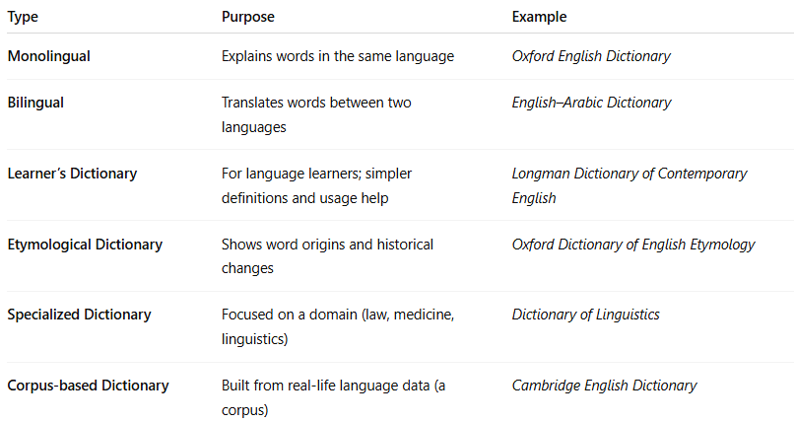
Type | Purpose | Example
Monolingual | Explains words in the same language | Oxford English Dictionary
Bilingual | Translates words between two languages | English–Arabic Dictionary
Learner’s Dictionary | For language learners; simpler definitions and usage help | Longman Dictionary of Contemporary English
Etymological Dictionary | Shows word origins and historical changes | Oxford Dictionary of English Etymology
Specialized Dictionary | Focused on a domain (law, medicine, linguistics) | Dictionary of Linguistics
Corpus-based Dictionary | Built from real-life language data (a corpus) | Cambridge English Dictionary

🧾 Dictionary Entries Include:
# Source: Chatgpt (GPT-4-turbo) at [7/23/2025]
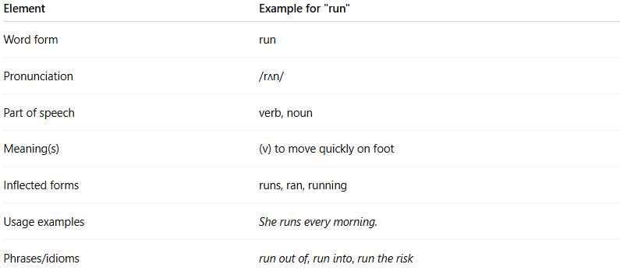
Element | Example for "run"
Word form | run
Pronunciation | /rʌn/
Part of speech | verb, noun
Meaning(s) | (v) to move quickly on foot
Inflected forms | runs, ran, running
Usage examples | She runs every morning.
Phrases/idioms | run out of, run into, run the risk

🧬 Linguistics vs. General Dictionaries:
# Source: Chatgpt (GPT-4-turbo) at [7/23/2025]
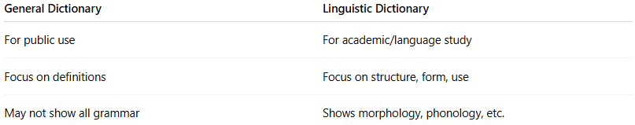
General Dictionary | Linguistic Dictionary
For public use | For academic/language study
Focus on definitions | Focus on structure, form, use
May not show all grammar | Shows morphology, phonology, etc.

✅ Summary:
# Source: Chatgpt (GPT-4-turbo) at [7/23/2025]
A dictionary in linguistics is a tool that systematically lists words of a language along with detailed linguistic information like form, meaning, pronunciation, and grammar.

2-Vocabulary

📚 What is Vocabulary?
# Source: Chatgpt (GPT-4-turbo) at [7/23/2025]
Vocabulary refers to the set of words that a person knows, understands, and uses in a language. It is the collection of words used for communicating ideas, emotions, and information.

📘 Definition:
# Source: Chatgpt (GPT-4-turbo) at [7/23/2025]
Vocabulary is the total number of words and expressions known or used by a person, group, or language.

🧠 Key Points:
# Source: Chatgpt (GPT-4-turbo) at [7/23/2025]
- Vocabulary is part of a speaker’s mental lexicon.
- It grows through reading, listening, speaking, and writing.
- It includes:
  - Words you understand (receptive vocabulary)
  - Words you use actively (productive vocabulary)

📂 Types of Vocabulary:
# Source: Chatgpt (GPT-4-turbo) at [7/23/2025]
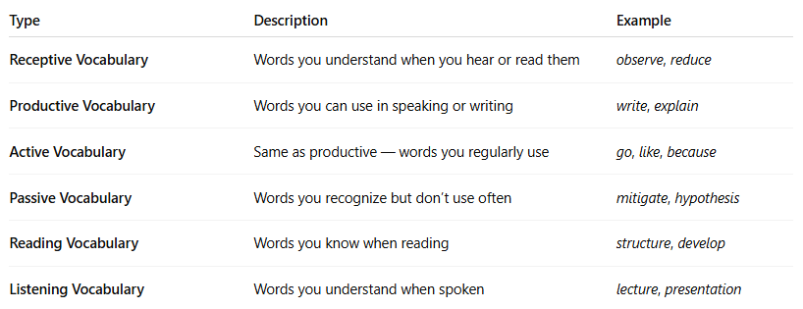

Type | Description | Example
Receptive Vocabulary | Words you understand when you hear or read them | observe, reduce
Productive Vocabulary | Words you can use in speaking or writing | write, explain
Active Vocabulary | Same as productive — words you regularly use | go, like, because
Passive Vocabulary | Words you recognize but don’t use often | mitigate, hypothesis
Reading Vocabulary | Words you know when reading | structure, develop
Listening Vocabulary | Words you understand when spoken | lecture, presentation

📈 Vocabulary in Language Learning:
# Source: Chatgpt (GPT-4-turbo) at [7/23/2025]
- Vocabulary size is often a key indicator of language proficiency.
- Learners build vocabulary through:
  - Reading
  - Contextual exposure
  - Flashcards or word lists
  - Practice in speaking/writing

🔄 Vocabulary vs Lexicon:
# Source: Chatgpt (GPT-4-turbo) at [7/23/2025]
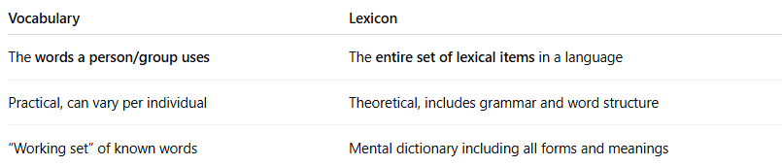

Vocabulary | Lexicon
The words a person/group uses | The entire set of lexical items in a language
Practical, can vary per individual | Theoretical, includes grammar and word structure
“Working set” of known words | Mental dictionary including all forms and meanings

Vocabulary vs Dictionary:
# Source: Chatgpt (GPT-4-turbo) at [7/30/2025]
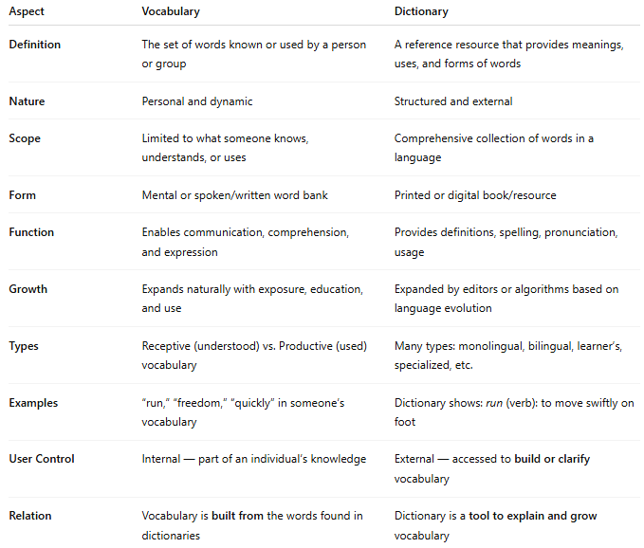

Aspect | Vocabulary | Dictionary
Definition | The set of words known or used by a person or group | A reference resource that provides meanings, uses, and forms of words
Nature | Personal and dynamic | Structured and external
Scope | Limited to what someone knows, understands, or uses | Comprehensive collection of words in a language
Form | Mental or spoken/written word bank | Printed or digital book/resource
Function | Enables communication, comprehension, and expression | Provides definitions, spelling, pronunciation, usage
Growth | Expands naturally with exposure, education, and use | Expanded by editors or algorithms based on language evolution
Types | Receptive (understood) vs. Productive (used) vocabulary | Many types: monolingual, bilingual, learner’s, specialized, etc.
Examples | “run,” “freedom,” “quickly” in someone’s vocabulary | Dictionary shows: run (verb): to move swiftly on foot
User Control | Internal — part of an individual’s knowledge | External — accessed to build or clarify vocabulary
Relation | Vocabulary is built from the words found in dictionaries | Dictionary is a tool to explain and grow vocabulary

📌 In Short:
- Vocabulary is what you know.
- Dictionary is what you use to learn and grow what you know.

✅ Summary:
# Source: Chatgpt (GPT-4-turbo) at [7/23/2025]
Vocabulary is the collection of words a person understands or uses in a language. It is central to communication, language learning, and comprehension.

3-Glossary

📗 What is a Glossary?
# Source: Chatgpt (GPT-4-turbo) at [7/23/2025]
A glossary is a list of specialized words or terms, usually found at the end of a book, along with definitions or explanations. It helps readers understand technical, unfamiliar, or field-specific vocabulary used in the text.

📘 Definition:
# Source: Chatgpt (GPT-4-turbo) at [7/23/2025]
A glossary is an alphabetical list of terms and their meanings, often related to a particular subject, text, or discipline.

🧠 Key Features:
# Source: Chatgpt (GPT-4-turbo) at [7/23/2025]
- Usually appears at the end of a book, article, or document.
- Provides clear, concise definitions of important or uncommon words.
- Terms are typically listed in alphabetical order.
- Focuses on domain-specific vocabulary (e.g., linguistics, medicine, law, business).

🔍 Example of a Glossary (in Linguistics):
# Source: Chatgpt (GPT-4-turbo) at [7/23/2025]
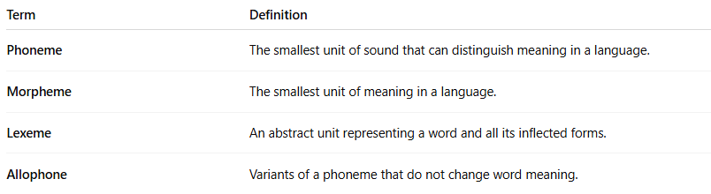

Term | Definition
Phoneme | The smallest unit of sound that can distinguish meaning in a language.
Morpheme | The smallest unit of meaning in a language.
Lexeme | An abstract unit representing a word and all its inflected forms.
Allophone | Variants of a phoneme that do not change word meaning.

🧾 Glossary vs Dictionary vs Lexicon:
# Source: Chatgpt (GPT-4-turbo) at [7/23/2025]
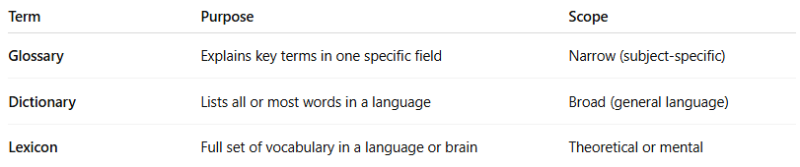

Term | Purpose | Scope
Glossary | Explains key terms in one specific field | Narrow (subject-specific)
Dictionary | Lists all or most words in a language | Broad (general language)
Lexicon | Full set of vocabulary in a language or brain | Theoretical or mental

✅ Summary:
# Source: Chatgpt (GPT-4-turbo) at [7/23/2025]
A glossary is a useful tool for understanding specialized vocabulary in a specific field or document.
It supports readers by giving simple explanations of complex or technical terms.

4-Diction

🗣️ What is Diction?
# Source: Chatgpt (GPT-4-turbo) at [7/23/2025]
Diction refers to the choice and use of words in speaking or writing. It affects the style, tone, and clarity of communication. In linguistics, it also sometimes relates to pronunciation and articulation.

📘 Definition:
# Source: Chatgpt (GPT-4-turbo) at [7/23/2025]
Diction is the selection of words and the way they are pronounced to express meaning clearly and effectively in spoken or written language.

🧠 Two Main Meanings of Diction:
# Source: Chatgpt (GPT-4-turbo) at [7/23/2025]
- Word Choice (Style) – how formal, informal, poetic, or technical your language is.
- Pronunciation (Speech Clarity) – how clearly and correctly you pronounce words.

🔍 1. Diction as Word Choice (in writing or rhetoric):
# Source: Chatgpt (GPT-4-turbo) at [7/23/2025]
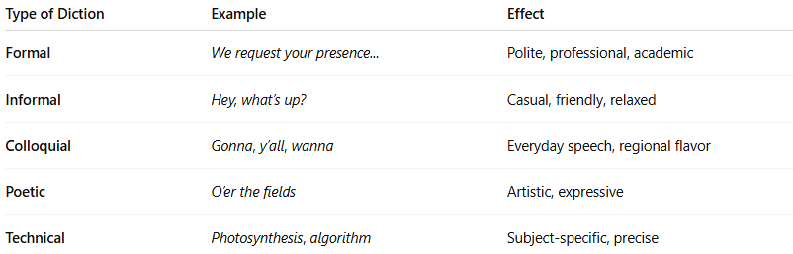

Type of Diction | Example | Effect
Formal | We request your presence... | Polite, professional, academic
Informal | Hey, what’s up? | Casual, friendly, relaxed
Colloquial | Gonna, y’all, wanna | Everyday speech, regional flavor
Poetic | O’er the fields | Artistic, expressive
Technical | Photosynthesis, algorithm | Subject-specific, precise

🔍 2. Diction as Pronunciation (in speaking):
# Source: Chatgpt (GPT-4-turbo) at [7/23/2025]
- Refers to how clearly someone speaks.
- Good diction means:
  - Clear articulation of sounds and syllables.
  - Proper pronunciation of words.
  - Avoiding mumbling, slurring, or overly fast speech.

🧾 Diction vs. Syntax vs. Vocabulary:
# Source: Chatgpt (GPT-4-turbo) at [7/23/2025]
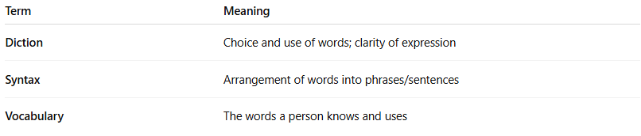
Term | Meaning
Diction | Choice and use of words; clarity of expression
Syntax | Arrangement of words into phrases/sentences
Vocabulary | The words a person knows and uses

Diction vs Glossary vs Vocabulary vs Dictionary
# Source: Chatgpt (GPT-4-turbo) at [7/30/2025]

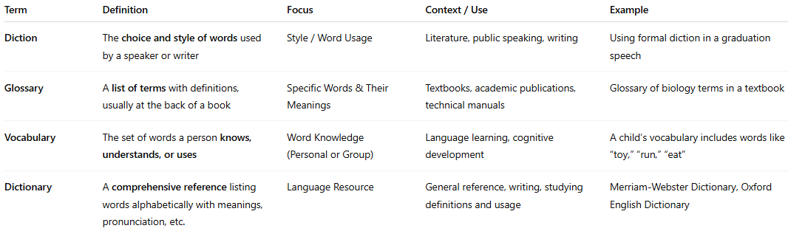

Term | Definition | Focus | Context / Use | Example
Diction | The choice and style of words used by a speaker or writer | Style / Word Usage | Literature, public speaking, writing | Using formal diction in a graduation speech
Glossary | A list of terms with definitions, usually at the back of a book | Specific Words & Their Meanings | Textbooks, academic publications, technical manuals | Glossary of biology terms in a textbook
Vocabulary | The set of words a person knows, understands, or uses | Word Knowledge (Personal or Group) | Language learning, cognitive development | A child’s vocabulary includes words like “toy,” “run,” “eat”
Dictionary | A comprehensive reference listing words alphabetically with meanings, pronunciation, etc. | Language Resource | General reference, writing, studying definitions and usage | Merriam-Webster Dictionary, Oxford English Dictionary

✅ Summary:
# Source: Chatgpt (GPT-4-turbo) at [7/23/2025]
Diction is about how you use and pronounce words — whether you’re writing a formal essay, giving a speech, or having a casual conversation.
It shapes your tone, style, and clarity.

5-Encyclopedia

📚 What Is an Encyclopedia?
# Source: Chatgpt (GPT-4-turbo) at [7/30/2025]
An encyclopedia is a reference work or digital resource that provides comprehensive, factual information on a wide range of subjects or on a specific field, usually organized alphabetically or topically.

🔹 Definition:
# Source: Chatgpt (GPT-4-turbo) at [7/30/2025]
An encyclopedia is a compilation of detailed and researched articles about various topics such as history, science, art, geography, and more, written to inform and educate.

🧠 Key Characteristics:
# Source: Chatgpt (GPT-4-turbo) at [7/30/2025]
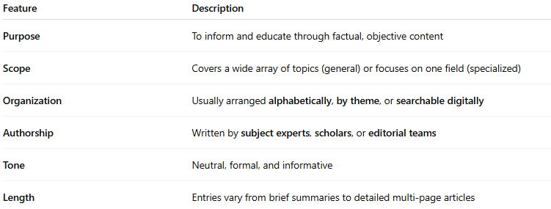
Feature | Description
Purpose | To inform and educate through factual, objective content
Scope | Covers a wide array of topics (general) or focuses on one field (specialized)
Organization | Usually arranged alphabetically, by theme, or searchable digitally
Authorship | Written by subject experts, scholars, or editorial teams
Tone | Neutral, formal, and informative
Length | Entries vary from brief summaries to detailed multi-page articles

🔸 Examples of Encyclopedias:
# Source: Chatgpt (GPT-4-turbo) at [7/30/2025]
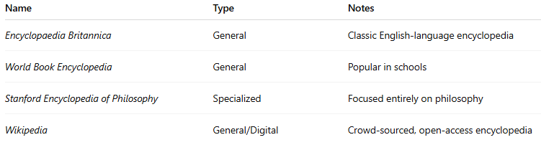
Name | Type | Notes
Encyclopaedia Britannica | General | Classic English-language encyclopedia
World Book Encyclopedia | General | Popular in schools
Stanford Encyclopedia of Philosophy | Specialized | Focused entirely on philosophy
Wikipedia | General/Digital | Crowd-sourced, open-access encyclopedia

📘 Encyclopedia vs Dictionary vs Glossary:
# Source: Chatgpt (GPT-4-turbo) at [7/30/2025]
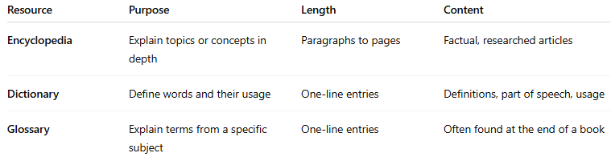

Resource | Purpose | Length | Content
Encyclopedia | Explain topics or concepts in depth | Paragraphs to pages | Factual, researched articles
Dictionary | Define words and their usage | One-line entries | Definitions, part of speech, usage
Glossary | Explain terms from a specific subject | One-line entries | Often found at the end of a book

